Clean Code Principles - Write Testable Code
# Source: AI Source: Provided by: [Data Path: Persons Table -> ID Column: 1, Name_En Column: Motasem Essam] -> From: [Chatgpt (GPT‑5 Mini)] on [12/9/2025]
Writing testable code means designing your code so it is easy to test automatically, especially with unit tests.
👉 If your code is hard to test, it’s usually a sign that the design needs improvement.

🔑 Why It Matters
# Source: AI Source: Provided by: [Data Path: Persons Table -> ID Column: 1, Name_En Column: Motasem Essam] -> From: [Chatgpt (GPT‑5 Mini)] on [12/9/2025]
- Helps detect bugs early
- Makes refactoring safer
- Encourages better design (SRP, loose coupling)
- Improves code quality and reliability

❌ Bad Example (Hard to Test)
# Source: AI Source: Provided by: [Data Path: Persons Table -> ID Column: 1, Name_En Column: Motasem Essam] -> From: [Chatgpt (GPT‑5 Mini)] on [12/9/2025]
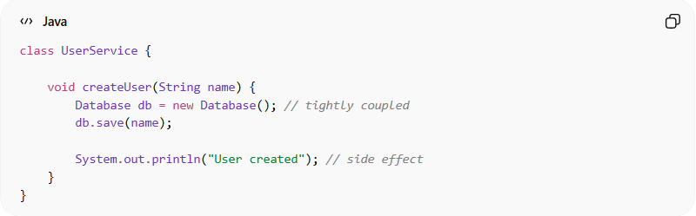
class UserService {

void createUser(String name) {
Database db = new Database(); // tightly coupled
db.save(name);

System.out.println("User created"); // side effect
}
}
👉 Problems:
- Direct dependency on Database
- Hard to mock or replace
- Uses console output (side effect)
- Cannot test in isolation

✅ Good Example (Testable Code)
# Source: AI Source: Provided by: [Data Path: Persons Table -> ID Column: 1, Name_En Column: Motasem Essam] -> From: [Chatgpt (GPT‑5 Mini)] on [12/9/2025]
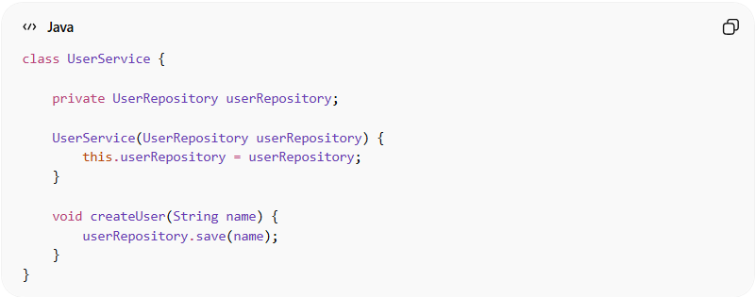
class UserService {

private UserRepository userRepository;

UserService(UserRepository userRepository) {
this.userRepository = userRepository;
}

void createUser(String name) {
userRepository.save(name);
}
}
👉 Benefits:
- Dependency is injected (easy to mock)
- No direct dependency on database
- Easy to test in isolation

✅ Example Test
# Source: AI Source: Provided by: [Data Path: Persons Table -> ID Column: 1, Name_En Column: Motasem Essam] -> From: [Chatgpt (GPT‑5 Mini)] on [12/9/2025]
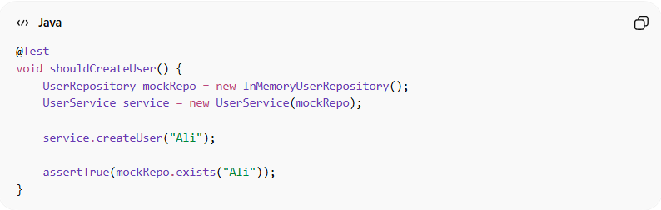
@Test
void shouldCreateUser() {
UserRepository mockRepo = new InMemoryUserRepository();
UserService service = new UserService(mockRepo);

service.createUser("Ali");

assertTrue(mockRepo.exists("Ali"));
}

🔧 Key Practices for Testable Code

1. Use Dependency Injection
# Source: AI Source: Provided by: [Data Path: Persons Table -> ID Column: 1, Name_En Column: Motasem Essam] -> From: [Chatgpt (GPT‑5 Mini)] on [12/9/2025]
- Pass dependencies instead of creating them inside
❌ Bad
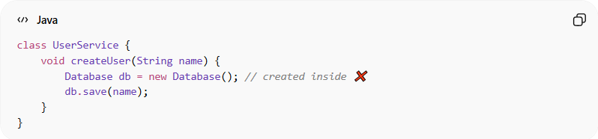
class UserService {
void createUser(String name) {
Database db = new Database(); // created inside ❌
db.save(name);
}
}
👉 Problem:
- Tightly coupled to Database
- Hard to test or replace
✅ Good
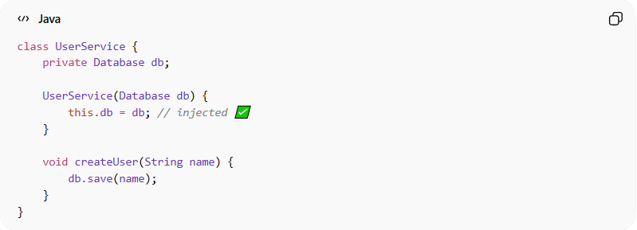
class UserService {
private Database db;
UserService(Database db) {
this.db = db; // injected ✅
}
void createUser(String name) {
db.save(name);
}
}
👉 Benefit:
- Easy to mock in tests
- Flexible and decoupled

2. Avoid Side Effects
# Source: AI Source: Provided by: [Data Path: Persons Table -> ID Column: 1, Name_En Column: Motasem Essam] -> From: [Chatgpt (GPT‑5 Mini)] on [12/9/2025]
- Don’t mix logic with I/O (printing, DB, API calls)
❌ Bad
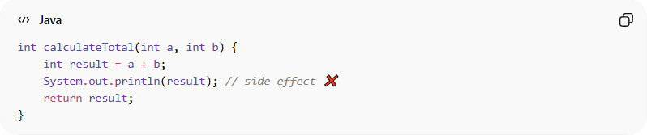
int calculateTotal(int a, int b) {
int result = a + b;
System.out.println(result); // side effect ❌
return result;
}

✅ Good
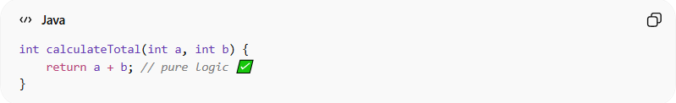
int calculateTotal(int a, int b) {
return a + b; // pure logic ✅
}
👉 Printing/logging should be done outside the function

3. Keep Functions Small
# Source: AI Source: Provided by: [Data Path: Persons Table -> ID Column: 1, Name_En Column: Motasem Essam] -> From: [Chatgpt (GPT‑5 Mini)] on [12/9/2025]
- Smaller functions are easier to test
❌ Bad
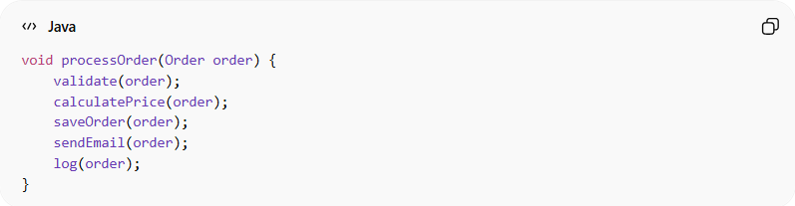
void processOrder(Order order) {
validate(order);
calculatePrice(order);
saveOrder(order);
sendEmail(order);
log(order);
}
👉 Too many responsibilities

✅ Good
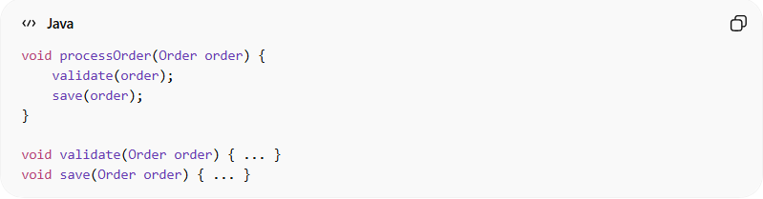
void processOrder(Order order) {
validate(order);
save(order);
}
void validate(Order order) { ... }
void save(Order order) { ... }
👉 Each function is focused and testable

4. Use Interfaces
# Source: AI Source: Provided by: [Data Path: Persons Table -> ID Column: 1, Name_En Column: Motasem Essam] -> From: [Chatgpt (GPT‑5 Mini)] on [12/9/2025]
- Allows mocking and flexibility
❌ Bad
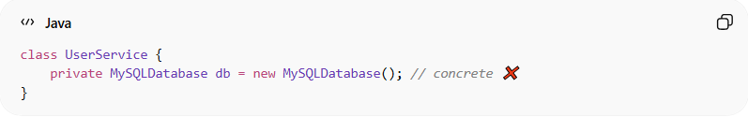
class UserService {
private MySQLDatabase db = new MySQLDatabase(); // concrete ❌
}
👉 Problem:
- Cannot replace database easily

✅ Good
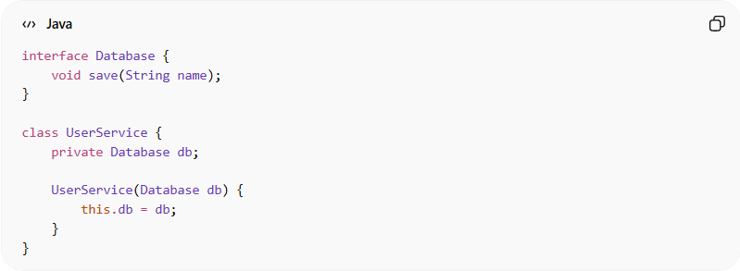
interface Database {
void save(String name);
}
class UserService {
private Database db;
UserService(Database db) {
this.db = db;
}
}
👉 Benefit:
- Can use mock or different implementations

5. Separate Logic from Framework
# Source: AI Source: Provided by: [Data Path: Persons Table -> ID Column: 1, Name_En Column: Motasem Essam] -> From: [Chatgpt (GPT‑5 Mini)] on [12/9/2025]
- Keep business logic independent
❌ Bad
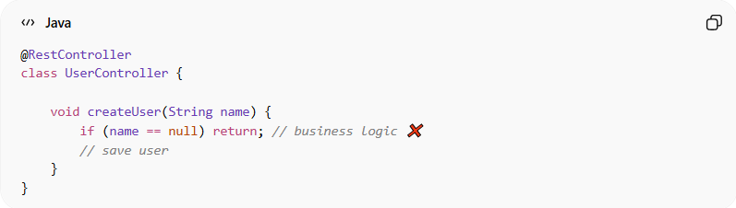
@RestController
class UserController {
void createUser(String name) {
if (name == null) return; // business logic ❌
// save user
}
}
👉 Problem:
- Logic mixed with framework

✅ Good
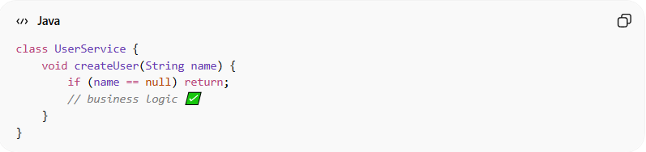
class UserService {
void createUser(String name) {
if (name == null) return;
// business logic ✅
}
}
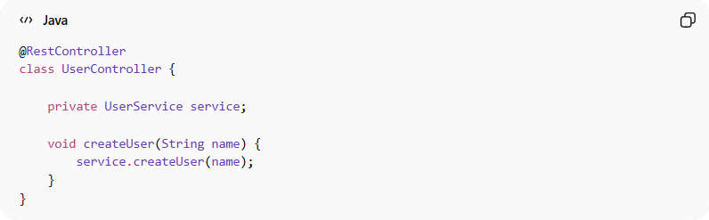
@RestController
class UserController {
private UserService service;
void createUser(String name) {
service.createUser(name);
}
}
👉 Benefit:
- Business logic is reusable and testable

💡 Key Idea
# Source: AI Source: Provided by: [Data Path: Persons Table -> ID Column: 1, Name_En Column: Motasem Essam] -> From: [Chatgpt (GPT‑5 Mini)] on [12/9/2025]
Code should be easy to test without complex setup or external dependencies.

🚫 Common Mistakes
# Source: AI Source: Provided by: [Data Path: Persons Table -> ID Column: 1, Name_En Column: Motasem Essam] -> From: [Chatgpt (GPT‑5 Mini)] on [12/9/2025]
- Creating dependencies inside classes
- Using static/global state
- Mixing business logic with infrastructure
- Writing large, complex methods

🧪⚡ Write Testable Code vs Write Fast and Independent Tests
# Source: AI Source: Provided by: [Data Path: Persons Table -> ID Column: 1, Name_En Column: Motasem Essam] -> From: [Chatgpt (GPT‑5 Mini)] on [12/9/2025]
These two principles are closely related but focus on different parts of development:
- Write Testable Code → how you write your production code
- Write Fast & Independent Tests → how you write your test code

1️⃣ 🧪 Write Testable Code (Production Code)
# Source: AI Source: Provided by: [Data Path: Persons Table -> ID Column: 1, Name_En Column: Motasem Essam] -> From: [Chatgpt (GPT‑5 Mini)] on [12/9/2025]
🎯 Focus
Design your code so it is easy to test
🔑 Goal
Make testing possible and simple

❌ Bad
# Source: AI Source: Provided by: [Data Path: Persons Table -> ID Column: 1, Name_En Column: Motasem Essam] -> From: [Chatgpt (GPT‑5 Mini)] on [12/9/2025]
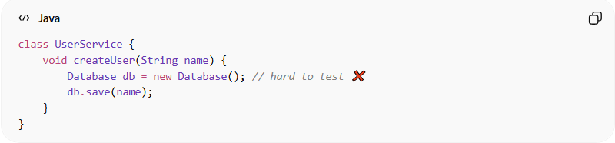
class UserService {
void createUser(String name) {
Database db = new Database(); // hard to test ❌
db.save(name);
}
}

✅ Good
# Source: AI Source: Provided by: [Data Path: Persons Table -> ID Column: 1, Name_En Column: Motasem Essam] -> From: [Chatgpt (GPT‑5 Mini)] on [12/9/2025]
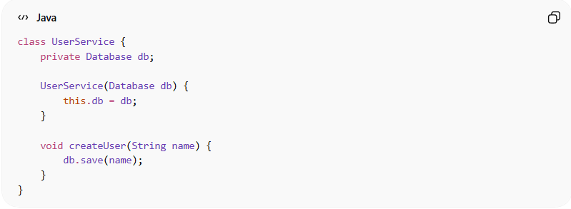
class UserService {
private Database db;

UserService(Database db) {
this.db = db;
}

void createUser(String name) {
db.save(name);
}
}

💡 Key Idea
# Source: AI Source: Provided by: [Data Path: Persons Table -> ID Column: 1, Name_En Column: Motasem Essam] -> From: [Chatgpt (GPT‑5 Mini)] on [12/9/2025]
“Can I test this easily without complex setup?”
If not → code design needs improvement

2️⃣ ⚡ Write Fast and Independent Tests (Test Code)
# Source: AI Source: Provided by: [Data Path: Persons Table -> ID Column: 1, Name_En Column: Motasem Essam] -> From: [Chatgpt (GPT‑5 Mini)] on [12/9/2025]
🎯 Focus
How your tests behave and run
🔑 Goal
Tests should be:
- Fast ⚡
- Independent 🔗❌

❌ Bad
# Source: AI Source: Provided by: [Data Path: Persons Table -> ID Column: 1, Name_En Column: Motasem Essam] -> From: [Chatgpt (GPT‑5 Mini)] on [12/9/2025]
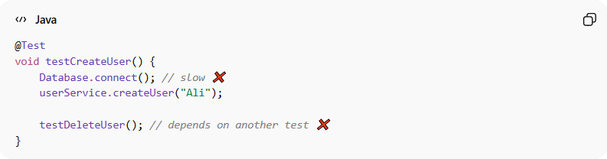
@Test
void testCreateUser() {
Database.connect(); // slow ❌
userService.createUser("Ali");

testDeleteUser(); // depends on another test ❌
}

✅ Good
# Source: AI Source: Provided by: [Data Path: Persons Table -> ID Column: 1, Name_En Column: Motasem Essam] -> From: [Chatgpt (GPT‑5 Mini)] on [12/9/2025]
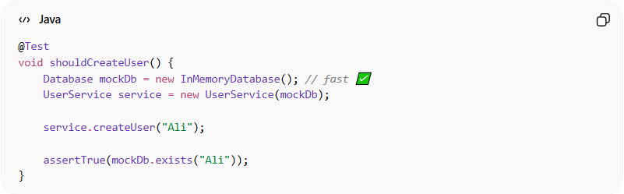
@Test
void shouldCreateUser() {
Database mockDb = new InMemoryDatabase(); // fast ✅
UserService service = new UserService(mockDb);

service.createUser("Ali");

assertTrue(mockDb.exists("Ali"));
}

💡 Key Idea
# Source: AI Source: Provided by: [Data Path: Persons Table -> ID Column: 1, Name_En Column: Motasem Essam] -> From: [Chatgpt (GPT‑5 Mini)] on [12/9/2025]
Each test should run quickly and independently, anytime

🔑 Key Differences
# Source: AI Source: Provided by: [Data Path: Persons Table -> ID Column: 1, Name_En Column: Motasem Essam] -> From: [Chatgpt (GPT‑5 Mini)] on [12/9/2025]
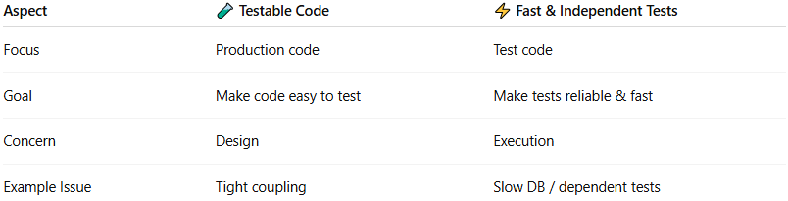
Aspect | 🧪 Testable Code | ⚡ Fast & Independent Tests
Focus | Production code | Test code
Goal | Make code easy to test | Make tests reliable & fast
Concern | Design | Execution
Example Issue | Tight coupling | Slow DB / dependent tests

🔗 Relationship Between Them
# Source: AI Source: Provided by: [Data Path: Persons Table -> ID Column: 1, Name_En Column: Motasem Essam] -> From: [Chatgpt (GPT‑5 Mini)] on [12/9/2025]
👉 They depend on each other:
- Good design → makes tests easy
- Good tests → validate your design
You can’t have good tests without testable code
And testable code is useless without good tests

🧾 Final Summary
# Source: AI Source: Provided by: [Data Path: Persons Table -> ID Column: 1, Name_En Column: Motasem Essam] -> From: [Chatgpt (GPT‑5 Mini)] on [12/9/2025]
- Write Testable Code → prepares your code for testing
- Write Fast & Independent Tests → ensures tests are efficient and reliable

🧾 Summary
# Source: AI Source: Provided by: [Data Path: Persons Table -> ID Column: 1, Name_En Column: Motasem Essam] -> From: [Chatgpt (GPT‑5 Mini)] on [12/9/2025]
Writing testable code helps you:
- Improve code design
- Catch bugs early
- Refactor safely
- Build reliable and maintainable systems

